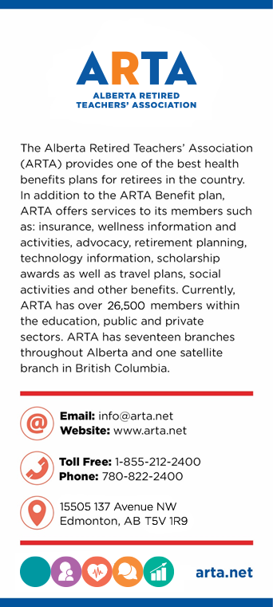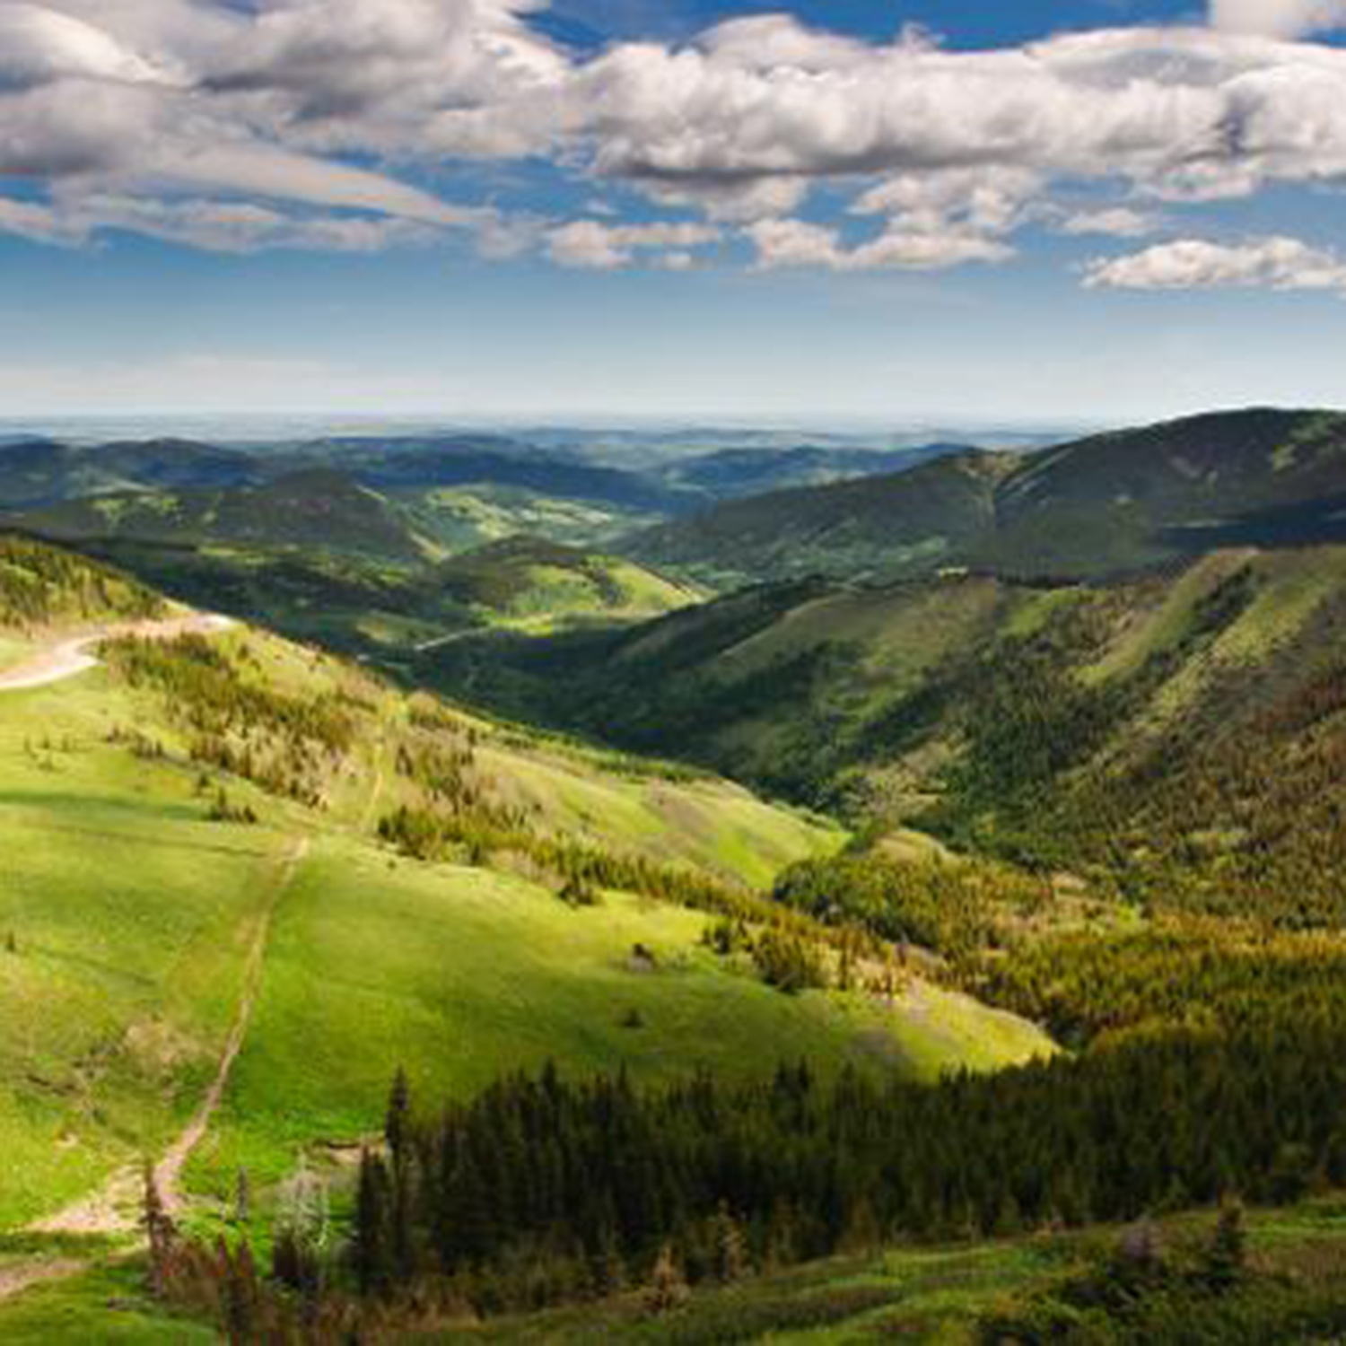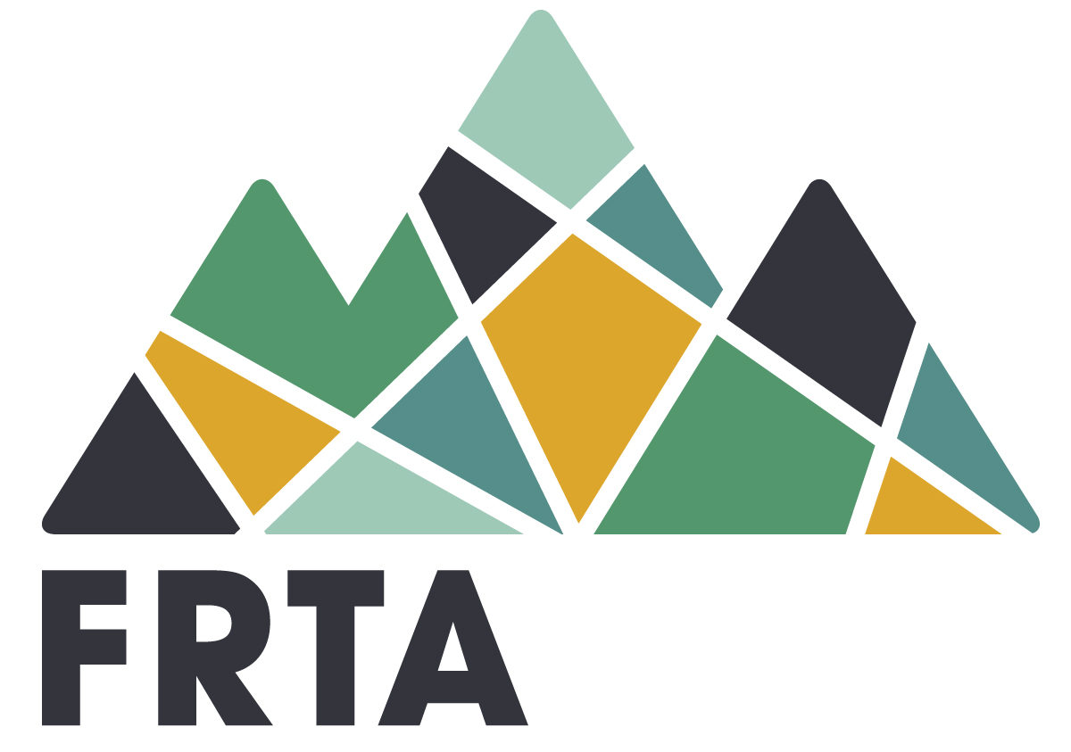

**Membership Eligibility**

Donec quis nunc. Curabitur labore. Ac augue donec, sed gravida a dolor luctus, congue arcu id diam praesent, pretium ac Ipsum puruspede,aliquet sed. Enim eros in vel, volutpat nec pellentesque leo, temporibus scelerisque nec.

Ac dolor ac adipiscing amet bibendum nullam, massa lacus molestie ut libero nec, diam et, pharetra sodales eget, feugiat ullamcorper id tempor eget id vitae. Enim eros in vel, volutpat nec pellentesque leo, temporibus scelerisque nec. Mauris pretium eget aliquet, lectus tincidunt. Porttitor mollis imperdiet libero senectus.

Foothills Retired Teachers’ Association

A Branch of the   
Alberta Retired Teachers’ Association



**Contact Us**

Title  
Name  
Number  
[Email](mailto:garysawa@shaw.ca)

Title  
Name  
Number  
[Email](mailto:garysawa@shaw.ca)

**Getting Involved**

Donec quis nunc. Curabitur labore. Ac augue donec, sed gravida a dolor luctus, congue arcu id diam praesent, pretium ac Ipsum puruspede,aliquet sed. Enim eros in vel, volutpat nec pellentesque leo, temporibus scelerisque nec.

Ac dolor ac adipiscing amet bibendum nullam, massa lacus molestie ut libero nec, diam et, pharetra sodales eget, feugiat ullamcorper id tempor eget id vitae. Enim eros in vel, volutpat

**Branch Activities**

Donec quis nunc. Curabitur labore. Ac augue donec, sed gravida a dolor luctus, congue arcu id diam praesent, pretium ac Ipsum puruspede,aliquet sed. Enim eros in vel, volutpat nec pellentesque leo, temporibus scelerisque nec.

Ac dolor ac adipiscing amet bibendum nullam, massa lacus molestie ut libero nec, diam et, pharetra sodales eget, feugiat ullamcorper id tempor eget id vitae. Enim eros in vel, volutpat nec pellentesque leo, temporibus scelerisque nec. Mauris pretium eget aliquet, lectus tincidunt. Porttitor mollis imperdiet libero senectus.

**Upcoming Events**

SAVE THE DATE  
ARTA’s 2018 Annual Golf Tournament will be hosted by FRTA in High River, Alberta, on June 21, 2018 at Highwood Golf and Country Club, beginning at noon. Registration details coming soon.

SAVE THE DATE  
ARTA’s 2018 Annual Golf Tournament will be hosted by FRTA in High River, Alberta, on June 21, 2018 at Highwood Golf and Country Club, beginning at noon. Registration details coming soon.

**About Branch Name**

Donec quis nunc. Curabitur labore. Ac augue donec, sed gravida a dolor luctus, congue arcu id diam praesent, pretium ac Ipsum puruspede,aliquet sed. Enim eros in vel, volutpat nec pellentesque leo, temporibus scelerisque nec.

Ac dolor ac adipiscing amet bibendum nullam, massa lacus molestie ut libero nec, diam et, pharetra sodales eget, feugiat ullamcorper id tempor eget id vitae. Enim eros in vel, volutpat nec pellentesque leo, temporibus scelerisque nec. Mauris pretium eget aliquet, lectus tincidunt. Porttitor mollis imperdiet libero senectus.